Invoice Outsort - PS Tolerance failure

Customer payment scheme increase above tolerance

**Tolerance Limit – Customer or Vendor Payment Differences**

**What is Tolerance?**

Minor differences between the Invoice amount and the amount received from the customers/amount paid to the vendors are a very common occurrence.

In such scenario, the following options can be adopted:

* The receipts/payments can be posted by partially clearing the invoices and creating a residual item for the difference, if the amount of difference is beyond a certain limit and is hence material
* The receipts/payments can be posted by clearing the invoices and creating a separate entry for the difference amount, if the amount of difference is within a certain limit and is hence immaterial

The above mentioned limit which controls whether a difference amount is material or immaterial is determined by the tolerance limit defined in the SAP system.

**Functioning of Tolerance in SAP:**

The way SAP system handles such a scenario can be controlled by carrying out relevant configurations and master data maintenance.

**Step 1 – The main activity to be done for using the concept of Tolerance in SAP is:**

* Analyzing the requirement for creating tolerance group
* If as per the business requirement there is a need to provide for tolerance in case of payment differences, then tolerance groups would have to be created as required
* Grouping together customers/vendors who should be assigned same tolerance limits
* Creating as many Tolerance Groups as there is a need to classify customers into different groups entitled to different tolerance limits

If there is no need to classify the customers/vendors into different groups, who are entitled to different tolerance limits, the requirement to assign tolerance group to customers/vendors can be met by creating blank tolerance group (as shown in the screenshot below).

Thus whenever any customer/vendor master is created the tolerance group in the master data can be left blank.The blank tolerance group would become automatically applicable to the customer/vendor.

**Step 2 – Define Tolerance Group:**

The tolerance limits would have to be defined by way of tolerance groups.

Tolerance Groups contain the details that control the way the system processes the cash discount and payment differences.

Further, the tolerance limits can be defined:

* Either as an absolute amount
* Or as a percentage of the amount received/paid

But the applicable tolerance limit would be the lower of either the absolute amount or the amount arrived at by calculating the percentage.

Tolerance Group would have to be created for Customers/Vendors and Users.

**Step 3 – Assignment of Tolerance Group:**

The tolerance limits would have to be assigned to the customers/vendors for each company code separately.

The tolerance limits would have to be assigned to the employees/users.

**Determining the Tolerance Amount Applicable:**

The tolerance which would be applicable in any scenario would be the least of the following:

* Either the absolute amount or the amount arrived at by calculating the percentage of the amount received/paid up to which payment differences are allowed to be posted for the customer/vendor as specified in the tolerance group applicable for the customer/vendor
* Or the absolute amount or the amount arrived at by calculating the percentage of the amount received/paid up to which payment differences are allowed to be posted by the user posting the invoice specified in the tolerance group applicable for the user

The maximum amounts would have to be defined separately for revenue as well as expenses.

**Posting of Payment Differences:**

The way the payment differences would be posted would depend upon whether:

* The payment difference amount is within the allowed cash discount tolerance amount and is a gain or
* The payment difference amount is within the allowed cash discount tolerance amount and is a loss or
* The payment difference amount exceeds the allowed cash discount tolerance amount

If the payment difference is within the maximum discount adjustment for gain/loss from payment differences, then the difference amount would be posted to the Cash Discount Adjustment account.

If the payment difference exceeds the maximum discount adjustment for gain/loss from payment differences, then the difference amount would be posted to the Payment Difference account.

**Step 4 – Automatic Determination of G/L Accounts to be posted to:**

The payment differences irrespective of, whether it exceeds or is within the permitted payment difference as per the tolerance groups, would have to be posted to G/L Accounts.

The G/L accounts to be posted to in both the abovementioned scenarios can be automatically determined as per the configuration settings in the SAP system.

**Step 4 A – Account to be posted to in case of payment differences beyond defined cash discounts:**

| **Description** | **Transaction Code** |
| --- | --- |
| **Maintain FI Configuration Automatic Posting – Accounts** | **OBXL** |

The General Ledger Account to which the payment difference should be posted in case it exceeds the permitted payment difference amount is assigned here:

[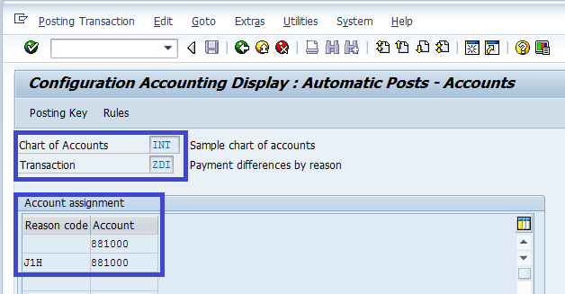](https://blogs.sap.com/wp-content/uploads/2013/02/payment_difference_account_188155.png)

**Step 4 B – Account to be posted to in case the payment difference gain is within defined Maximum Discount Adjustment Amount for Gain from Payment Differences:**

| **Description** | **Transaction Code** |
| --- | --- |
| **Maintain FI Configuration Automatic Posting – Accounts** | **OBXU** |

In the scenarios where the payment difference is a gain and should be adjusted to the Cash Discount Gains account, the General Ledger Account to which it should be posted is assigned here:

[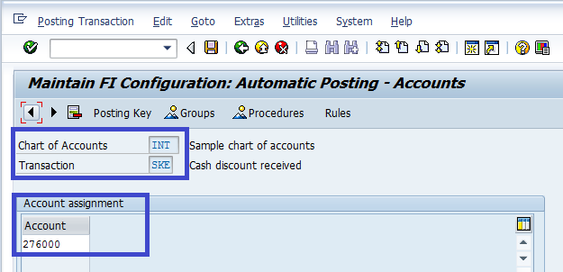](https://blogs.sap.com/wp-content/uploads/2013/02/cash_discount_received_account_188180.png)

**Step 4 C – Account to be posted to in case the payment difference loss is within defined Maximum Discount Adjustment Amount for Loss from Payment Differences:**

| **Description** | **Transaction Code** |
| --- | --- |
| **Maintain FI Configuration Automatic Posting – Accounts** | **OBXI** |

In the scenarios where the payment difference is a loss and should be adjusted to the Cash Discount Loss account, the General Ledger Account to which it should be posted is assigned here:

[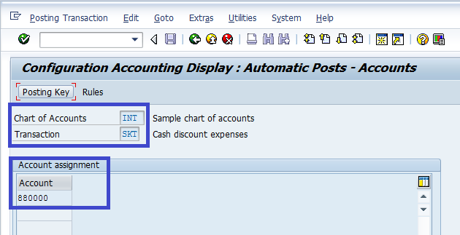](https://blogs.sap.com/wp-content/uploads/2013/02/cash_discount_expense_account_188181.png)

**Step 5 – Specification of Customer/Vendor Tolerance Group:**

| **Description** | **Transaction Code** |
| --- | --- |
| **Customer/Vendor Tolerances** | **OBA3** |

For each company code, the specifications for the tolerance groups for customers/vendors would have to be configured, which would control:

* the permitted payment differences in terms of either absolute amounts for gains or losses or
* the permitted payment differences in terms of percentages for gains or losses and
* the limit till which the cash discounts can be adjusted for gains or losses for customers/vendors

[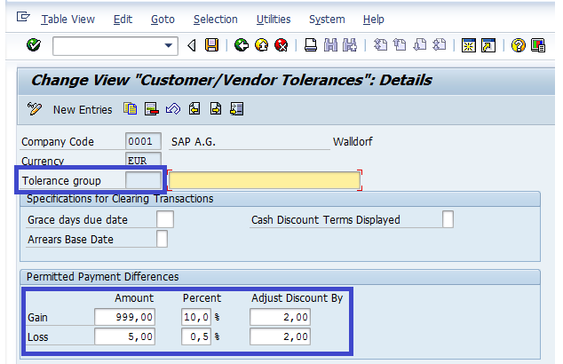](https://blogs.sap.com/wp-content/uploads/2013/02/tolerance_group_for_customers_vendors1_188794.png)

**Step 6 – Specification of User Tolerance Group:**

| **Description** | **Transaction Code** |
| --- | --- |
| **User Tolerances** | **OBA4** |

For each company code, the specifications for the tolerance groups for user would have to be configured, which would control:

* the permitted payment differences in terms of either absolute amounts for gains or losses or
* the permitted payment differences in terms of percentages for gains or losses and
* the limit till which the user is authorized to adjust the cash discounts for gains or losses

[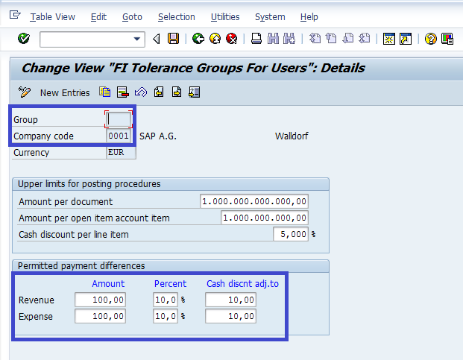](https://blogs.sap.com/wp-content/uploads/2013/02/tolerance_group_for_users_188198.png)

**Step 7 – Assignment of Tolerance Group to Customer:**

| **Description** | **Transaction Code** |
| --- | --- |
| **Create/Change Customer Master Data** | **FD01/FD02/XD01/XD02** |

The tolerance group configured above shall have to be assigned to the customer master.

[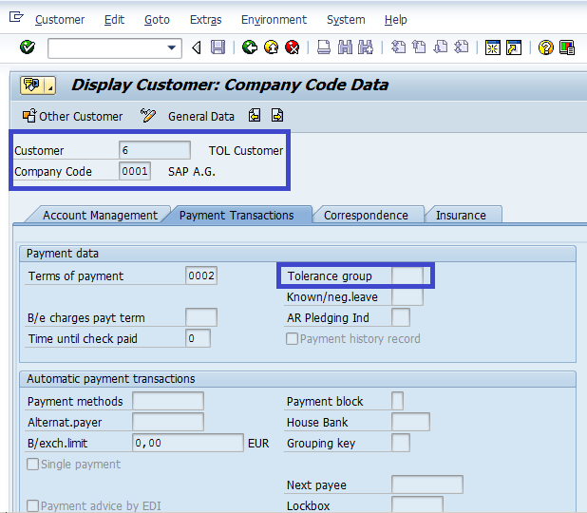](https://blogs.sap.com/wp-content/uploads/2013/02/assign_tolerance_group_to_customer_188199.png)

**Step 8 – Assignment of Tolerance Group to Users:**

| **Description** | **Transaction Code** |
| --- | --- |
| **Assign Users to Tolerance Group** | **OB57** |

The tolerance group configured above shall have to be assigned to the User.

[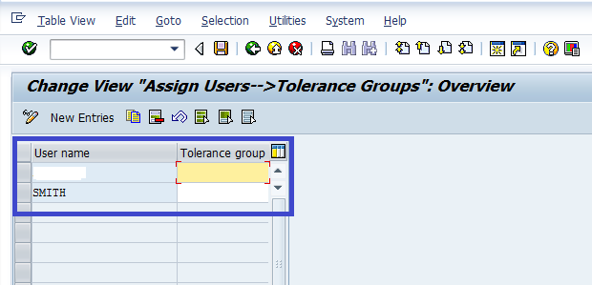](https://blogs.sap.com/wp-content/uploads/2013/02/assign_tolerance_group_to_user_188793.png)

**Illustration of Functioning of Tolerance in SAP:**

**Illustration Step 1 – Post Customer Invoice:**

| **Description** | **Transaction Code** |
| --- | --- |
| **Post Customer Invoice** | **FB70** |

An invoice is posted:

* against the above customer who is assigned the Blank tolerance group
* by the user shown above who is assigned the Blank tolerance group

[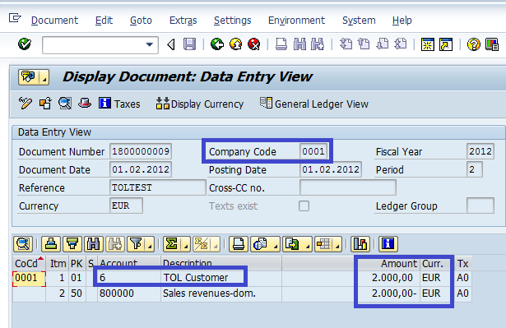](https://blogs.sap.com/wp-content/uploads/2013/02/customer_invoice_188200.png)

**Permitted Payment Difference as per Tolerance Group – Blank:**

As per the tolerance group assigned to the customer master as well as the user, the following payment differences are permitted:

* Payment difference of an amount upto 5 EUR(as per absolute amount specified)

* Payment difference of an amount upto 10 EUR(as per % specified)

Hence the maximum permitted payment difference as per the tolerance group assigned to the customer master as well as the user is 5 EUR.

**Illustration Step 2 – Post Incoming Payment with payment difference exceeding the permitted amount as per the Tolerance Group Blank:**

| **Description** | **Transaction Code** |
| --- | --- |
| **Post Incoming Payment** | **F-28** |

The customer is entitled to a 2% cash discount which is EUR 40 as per the payment term assigned to the customer.

* Amount of Invoice                                                      =  EUR 2000
* Cash Discount entitlement as per payment term – 2%  =  EUR 40
* Correct amount to be received for clearing the invoice   =  EUR 1960
* Permitted payment difference                                     =  EUR 5

An incoming payment is posted against the above customer for EUR 1940 (with a payment difference amount of EUR 20, which is beyond the permissible payment difference amount or EUR 5, as per the tolerance group – Blank).

When the document is tried to be saved an error message is displayed:**The difference is too large for clearing**

[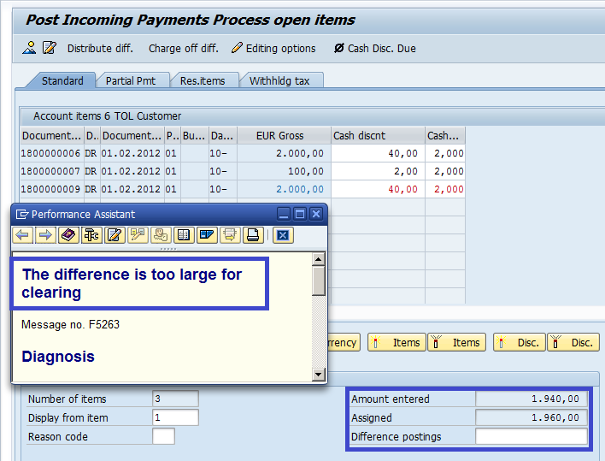](https://blogs.sap.com/wp-content/uploads/2013/02/error_message___exceeding_tolerance_188210.png)

**Illustration Step 3 – Post Incoming Payment with payment difference within the permitted amount as per the Tolerance Group Blank:**

| **Description** | **Transaction Code** |
| --- | --- |
| **Post Incoming Payment** | **F-28** |

Once again an incoming payment or EUR 1956 is tried to be posted against the same customer for the same invoice, but this time with a payment difference or EUR 4, which is within the permissible payment difference of 5 EUR.

The incoming payment is successfully posted against the customer, clearing the invoice.

[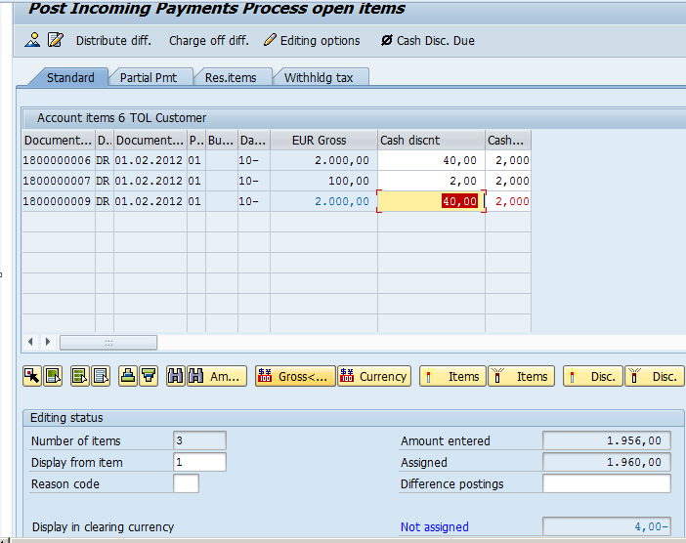](https://blogs.sap.com/wp-content/uploads/2013/02/payment_difference_within_permissible_limit_188211.png)

[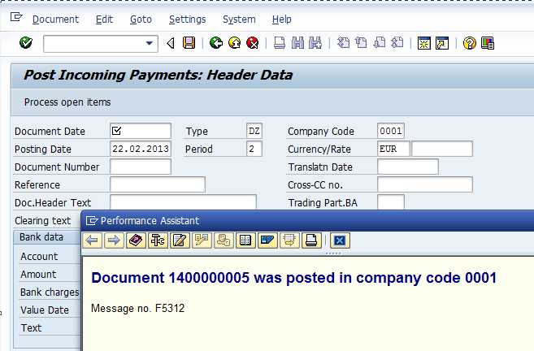](https://blogs.sap.com/wp-content/uploads/2013/02/document_posted_188212.png)

[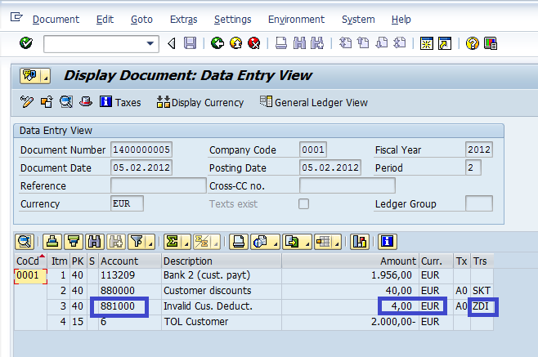](https://blogs.sap.com/wp-content/uploads/2013/02/payment_difference_posted_to_account_188225.png)

**Conclusion:**

Hence it can be concluded that:

* if the payment difference exceeds the amount defined as maximum permissible payment difference as per the tolerance group assigned to the customer and user, the system will display an error message.
* if the payment difference is within the amount defined as maximum permissible payment difference as per the tolerance group assigned to the customer and user, the system automatically posts the difference to the payment difference account configured in transaction code OBXL as described above.

# 